**【Basic Info.】**

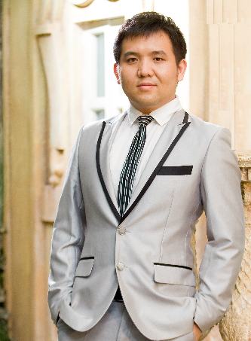

Name: **ZHANG MINGWEI**

IC/Passport No: **S7977757I**

Gender: **Male**

Birth: **21-July-1979**

Age: **38**

Nationality: **Singapore Citizen**

Race: **Chinese**

VISA IN USA: **H1B1**

**【Contacts.】**

Mobile: **65-97998378(Singapore)**

Email（Prefer）: [mwzhang@outlook.com](mailto:mwzhang@outlook.com)

Web Portal (Digital CV): <http://www.mwzhang.me>

Personal Blog: <http://mwzhang.blogspot.com/>

Link In: linkedin.com/in/mingwei-zhang-b911b4107

**【I am looking for below Career. 】**

* **IT/Engineering/BI/SAP Manager;**
* **Supply Chain Operation Manager(Order, Fulfillment, Inventory, RMA);**
* **Technical Solution Provider (Hardware & Software);**
* **Warehouse Management System Integration(AGV solution) ;**
* **Online Business (B2B, B2Bi, B2C) Solution or Consultant (End 2 End Complete solution include product);**
* **Complex system integration , development and deployment;**
* **OEM or 3rd party manufacturing process/IT solution, support and management;**
* **Professional Project Manager;**
* **Cross boarder business operation manager (China, US, APJ);**
* **Workaholic, and Can be trusted person in this world;**

**【Education.】**

**Year 2003 Diploma Singapore NanYang Polytechnic School**

* Diploma In Manufacturing Engineering
* Specialized in Automation System Design and Plastic Module Design
* Participate the Singapore Robotic Games (Y2003), independently working on Sumo Robot design
* Join Nanyang Polytechnic Chinese Culture club
* Form live band (Mercury) in Sambawang CC, and have a chance to perform in Singapore President Tony Tan birthday party.

**Year 2014 Bachelor Oxford Brookes University**

* BACHELOR OF SCIENCE (HONS) IN INFORMATION SYSTEMS AND SOFTWARE ENGINEERING
* Grade B/2nd Class Upper
* Final Year Dissertation is e-Bidding system.

**【Professional Experience.】**

**Y2003- Y2004 Mentor Media Singapore**

* IT/Process Engineer ;
* MS Licensing and HP project related
* Production system support ;
* IT System Analysis;
* SQL/VBA report Coding (inventory report, aging report, shipment report, backlog report,etc);

**Y2005 - Y2011 (Jun) Mentor Media China (Shanghai, Suzhou, Wuhan, Shenzhen, Chongqing, Tianjin, Yantai, Xiamen)**

* IT & Engineering Manager;
* New Branch Setup;
* Involve HP Project bidding (IT system architect );
* Fast fulfillment IT system integration;
* CTO type Inventory management ;
* Intelligent Production line (Vision System and Barcode scanning);
* Warehouse Management;

**Y2011 (Jul) - Y2017 (Feb) HP (Hewlett-Packard) Asia Singapore**

* Manager II (SME in Customer Master Data);
* OTO, OTC(Opportunity To Order, Order To Cash);
* SAP Order Support;
* HP Split project, Project manager ;
* 6 month in Austin, HP and HPE sales process discussion;
* B2B and B2Bi system integration;
* Sales Process ;

**Y2017 (Apr) - Y2018 (Aug) Mentor Media USA (California)**

* IT/Engineering Lead (Tech Lead)
* 3PL Project
* System Integration/ Support /Onboarding
* Warehouse Management System Design & Implementation
* HP Battery Recall Program
* Dell PPID and Media Support Process
* Amazon/shoplift system integration with WMS
* BOSE Refurbish / Testing system and Process design
* Report to regional VP directly

**Y2018 (Aug) – Now FTDI Singapore**

* IT/SAP/BI Manager (UK, US, CN, TW, SG, VN);
* Report to Engineering Director and COO;
* Overall IT infrastructure & operation support;
* Overall system integration;
* SAP/BO system process;
* Business intelligent system design and setup (Reporting, Sales Report, Production Report, Inventory Report, Aging Report);
* SAP B1 integration with WMS;
* Product traceability system design;
* All IT project

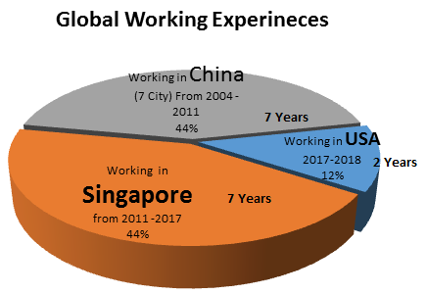

**【Data About ME.】**

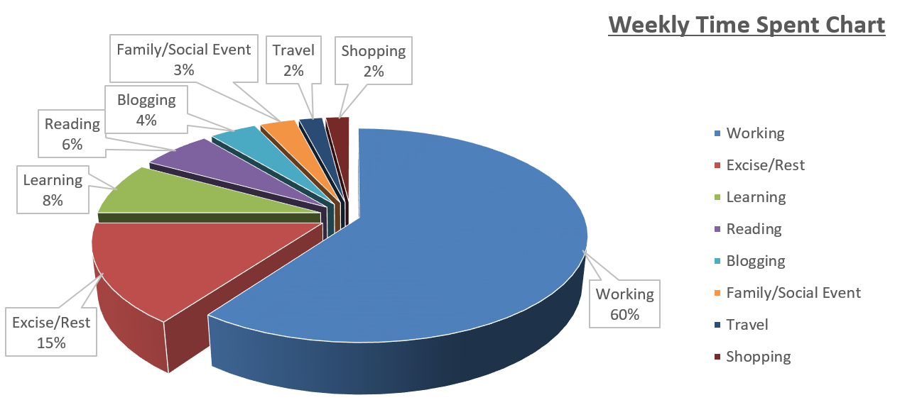

**Skillset Self-Evaluation**

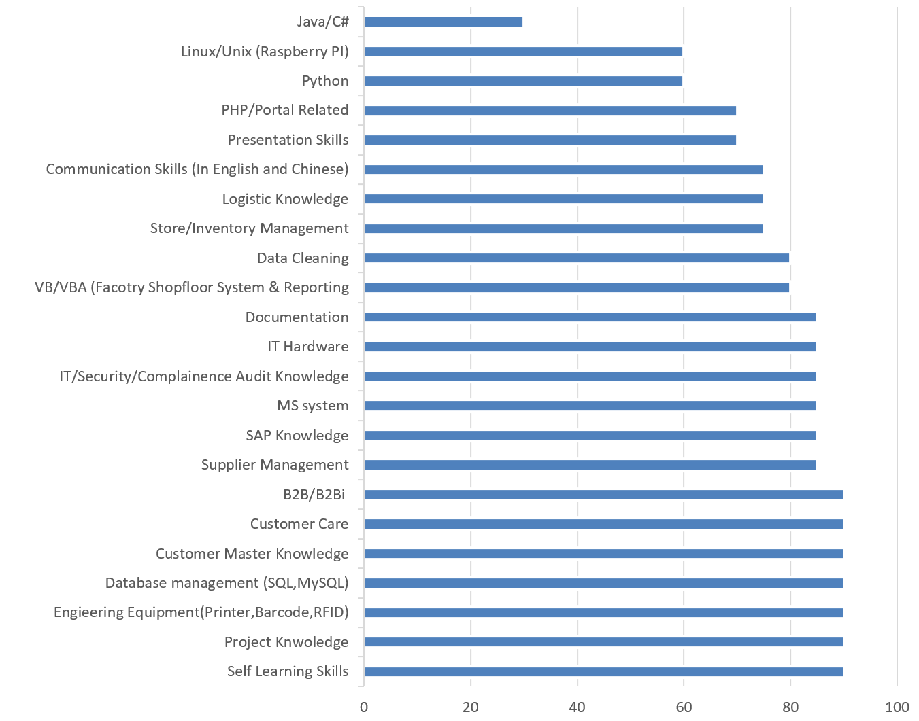

**【Objective.】**

* Result-oriented and IT/Tech background with 7 years working experience as Process Engineer and system analysis and 3 years Project Manager /SME Experience in world-class IT leading corp.
* 8 year Engineering Manager experience to pull whole team synergy to contribute for company
* Always looking for technical method to analyze and improve business processes. Ability to work well both independently and collaboratively. Able to work in a fast-paced and dynamic environment.
* Good learning skill in new knowledge with creative, productive thinking.
* Deeply understand customer requirements and nurturing client relation-ship. Experienced in Microsoft, HP Project management and Process Design/improvement.
* Save each single cent for company. Company business is my own business.
* Keep learning and Document it down the whole life.

**【Capability.】**

* **Mother language level** in **Mandarin** both speaking and writing;
* **Business professional** in **English** both speaking and writing;
* **Intermediate Level** in **Japanese** both speaking and writing;
* Good Manufacturing Engineering Knowledge, such as Time study, Process flow design, New Product Intro, Production line balancing, Inventory control. QA, GP and Lean6;
* Good Experience in new factory setup, such as recruitment, equipment purchase & setup, company license, tax or export & import license application, Factory facility renovation, especially in system security or factory security, staff Training, system deployment and BOM setup etc.;
* Good Skill in all different kinds of shopfloor system, web system and database design, such as, VB/VBA, PHP, SQL, MySQL, MariaDB etc. Used to be involved HP SFNG, SAP/Fusion, SFDC, OIS, OSS, Beacon system training;
* Rich Experience in the factory hardware and IT equipment. Zebra Label Printer (enable to disassembly and assembly the whole Zebra printer.), PLC production line, 1D/2D Barcode scanner, factory camera visual system;
* Good Operation Experience in supply chain, call center, fast fulfillment and logistic;
* Good Security Sense for all compliance project; used to work on the Microsoft Security Related Project;
* Good Experience in handling all kinds of audit, such Microsoft compliance audit, Microsoft security audit. HP ESD Engineering Audit;
* Good Study and Deep Dive capability, such as Payroll system started from “0”, and hands on within 2 months;
* Able to talk to customer and fully understand customer requirement and develop system or process to win customer deal;
* With good IT hardware knowledge, enable to follow instruction to assembly hardware and setup the APACHE server, VPN, Email Server, FTP/SFTP server, file server, and build up secure office networking. Write simple shell script to manage the Linux server;
* Good Habit to write “how to” documents, learning journal in work and real life. Refer to my personal Blog http://mwzhang.blogspot.sg/
* Project Management Skill with LSS Green Belt Certificate;
* Familiar with those China ODM and China Government officer;
* Familiar with US working and business environment;
* Business Traveling Adaptation;

**【Reference URL.& Design 】**

* [MW.Zhang Photograph Work | 个人摄影作品集](http://photo.163.com/ilovezmw/#m=0&p=1)
  + http://photo.163.com/ilovezmw/#m=0&p=1
* [MW.Zhang LiveBand Performance | 本人乐队表演](http://www.youtube.com/watch?v=NTfeaQIyBzE)
  + http://www.youtube.com/watch?v=NTfeaQIyBzE
* [MW.Zhang Piano Clips | 钢琴练习片断](http://www.youtube.com/watch?v=jEQq_JFNVag)
  + http://www.youtube.com/watch?v=jEQq_JFNVag
* [Guitar Play | 吉他练习](https://sites.google.com/)
  + http://www.youtube.com/watch?v=wlrwLkPIYtQ
* [MW.Zhang Music Recording and Post Processing for my wife | 音乐后期录音处理](https://soundcloud.com/ming-wei-16/the_moon)
  + <https://soundcloud.com/ming-wei-16/the_moon>
* PHP Portal Design | PHP网站设计作品
  + [www.lillybellesg.com](http://www.lillybellesg.com)
  + [www.mybino.com](http://www.mybino.com)
* [Warehouse Management Automation System Design](https://youtu.be/xjmJFhwHv0k) |智能仓库设计
  + https://youtu.be/xjmJFhwHv0k

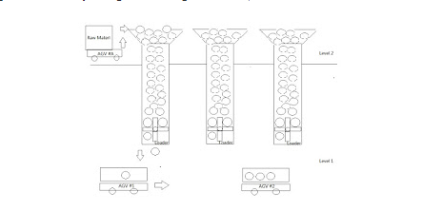

**[Good Communication and Learning Sample.]**

Regular 1:1 review with Personal Mentor and Manager

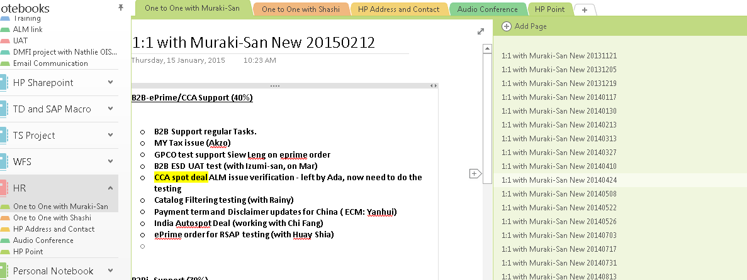

“How To” Knowledge Documentation

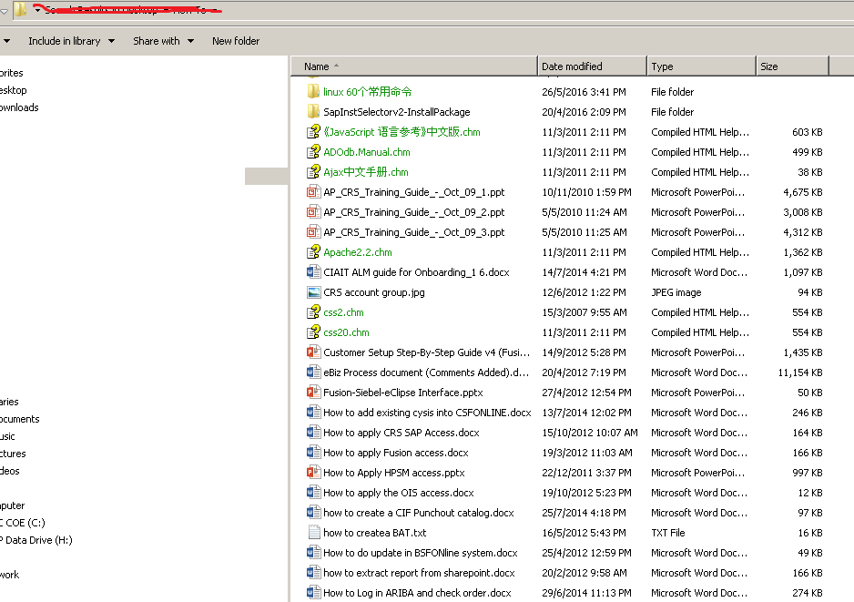

Personal IT knowledge Blog

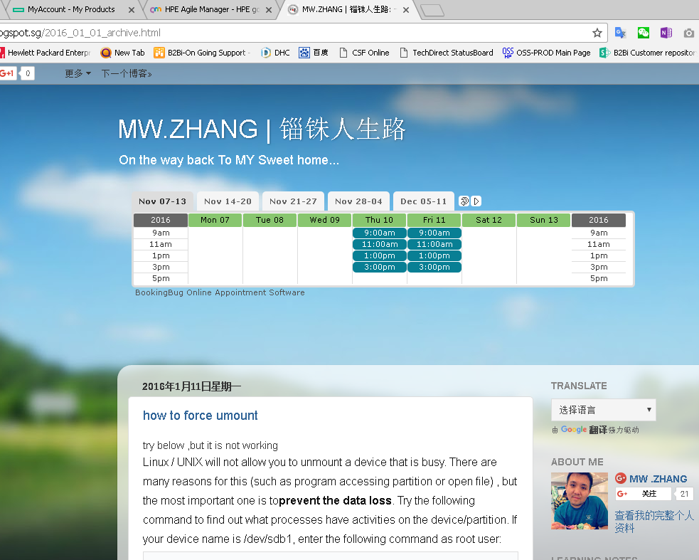

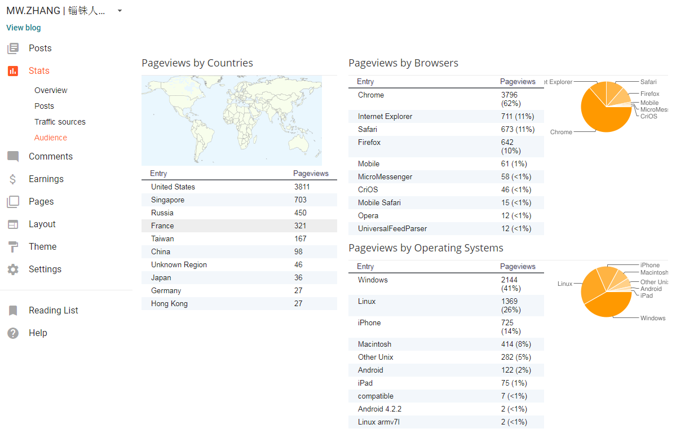

**【AWARD & RECOGNIZATION.】**

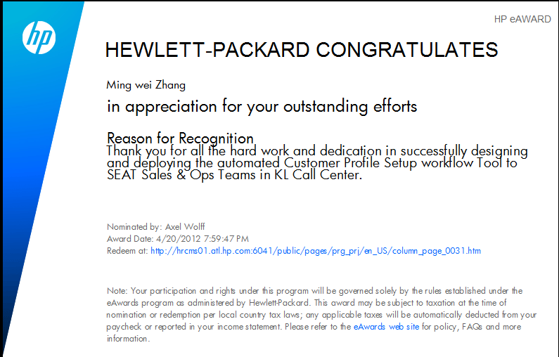

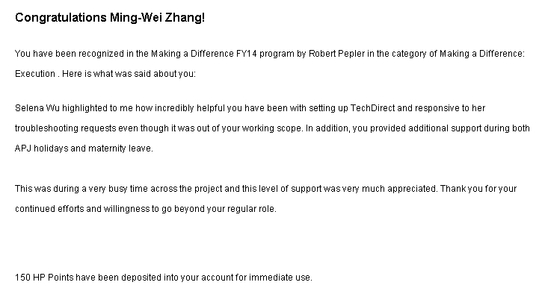

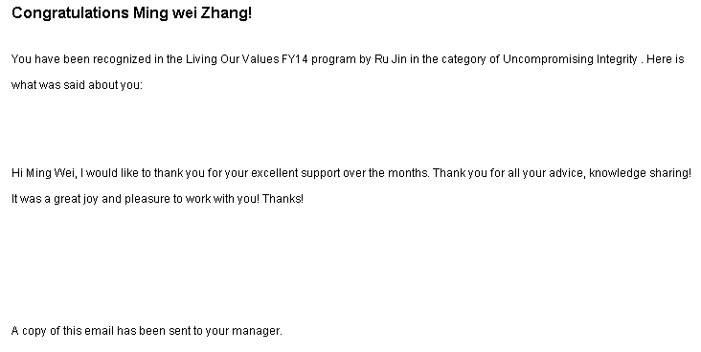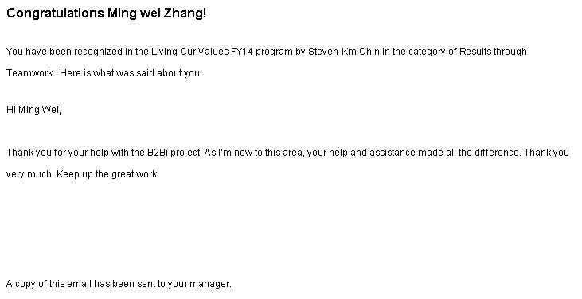

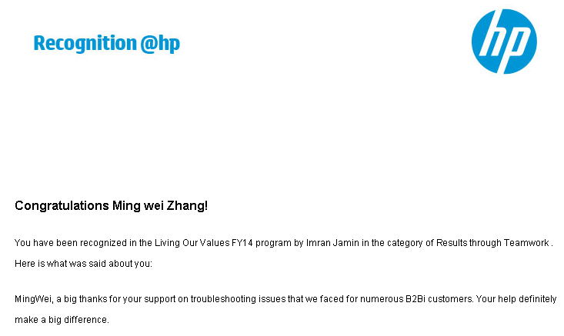

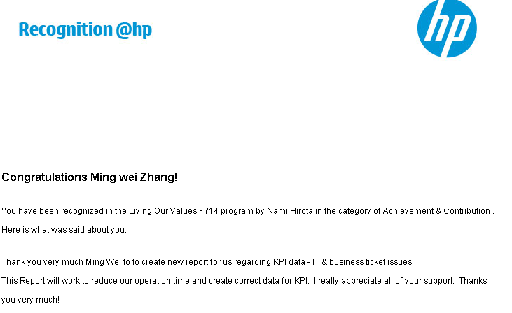

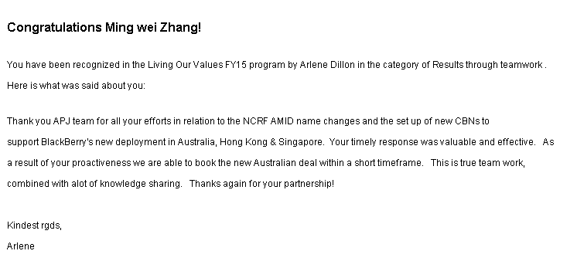

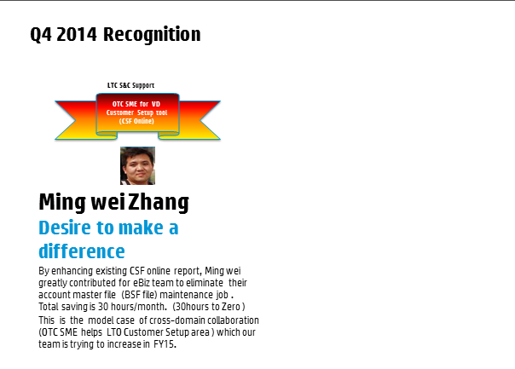

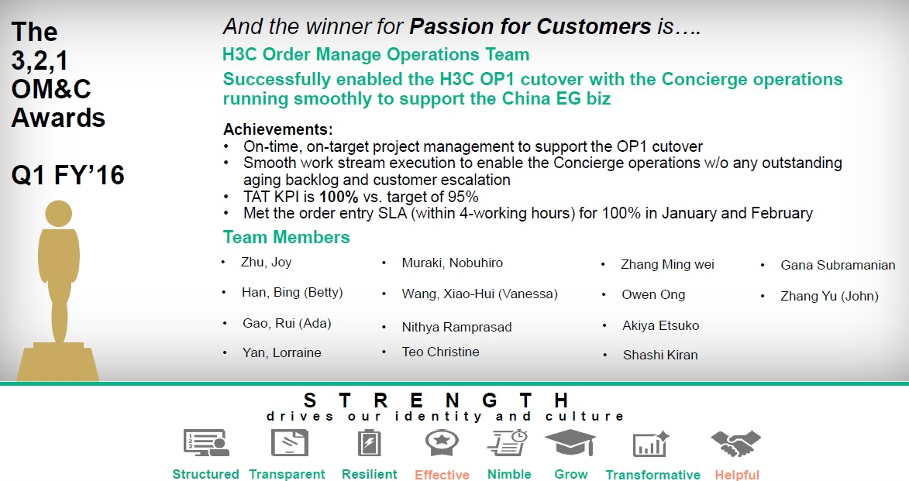

------END FOR NOW------